**Alert Management Tool**

**Software & System Implementation Documentation**

December 1, 2017

Version 1.0

Table of Contents

1 Document Conventions 3

2 Executive Summary 4

3 Proposed Solution 5

3.1 Architecture Diagram 5

3.2 Pi Data Collection 6

3.3 Azure Function 6

3.4 Stream Analytics 6

3.5 Alert Management Tool (AMT) 6

3.6 Alert Analytics Data Structure 9

4 Future State 15

4.1 Azure Machine Learning 15

4.2 IoT 15

4.3 BOT Framework 15

# Document Conventions

To help the reader understand text formatting conventions used in this document, the following conventions will be used.

* Hyperlinks to website URLs, server UNC paths and references to other sections within this document are underlined and formatted in blue.
  + Examples:  [Kimball Design Tips](http://www.kimballgroup.com/html/designtips.html) or <http://www.kimballgroup.com/html/designtips.html>

Examples: Document Conventions

* Field names, table names and other onscreen objects will be listed in **bold**.
* Code Samples are placed in a separate box and are displayed using a fixed width font (i.e., Courier New, 10 pt.) in the following formats:

--Comments are in GREEN

--SQL Keywords are normally in ALL CAPS

--SQL Commands are in BLUE

--SQL Object names are in PINK or BLACK

--Depending on usage, SQL Keywords may be in GREY

SELECT

c.object_id

,OBJECT_NAME(c.object_id) AS TableName

, c.column_id

, isc.COLUMN_NAME

FROM information_schema.columns isc

INNER JOIN sys.columns c ON isc.column_name = c.name

# Executive Summary

This guide provides information on the features and capabilities of the AMT solution. Information in the document has been organized into two sections. Current state details the current capabilities of the solution. Future state shows potential future capabilities built from the current functionality.

* Proposed Solution
  + Architecture Diagram
  + Pi Data Collection – Pi API is leveraged to push data into Blob Storage
  + Azure Function – data collected at defined interval
  + Stream Analytics – Queries to filter, sort aggregate and join streaming data
  + Alert Management Tool – User interface to create, manage and set notification method of alerts
  + Alert Analytics – Power BI dashboard to analyze PIC performance as related to alert metrics (e.g. length of time alert is active)
* Future State
  + Azure Machine Learning
    - Leverage historical Pi data to capture failures and leverage alerts to predict failures
    - Efficacy analysis
    - What if scenarios
  + IoT – add devices to receive alerts and take action to connect and control sensors and equipment for Drilling and Operations
  + BOT Framework - as alerting and actions mature, bots can provide a communication channel to various teams/individuals throughout the company

# Solution

The AMT solution provides an easy way to cut through the huge influx of available data and present the most pertinent and urgent alerts to the person in charge (PIC) during the hydraulic fracturing process. There are two categories of alerts available. The default alerts are set by the completions engineers. These alerts are not editable by the PIC. The second set of alerts are created and configured by the PIC.

## Architecture Diagram

**Infrastructure Architecture:**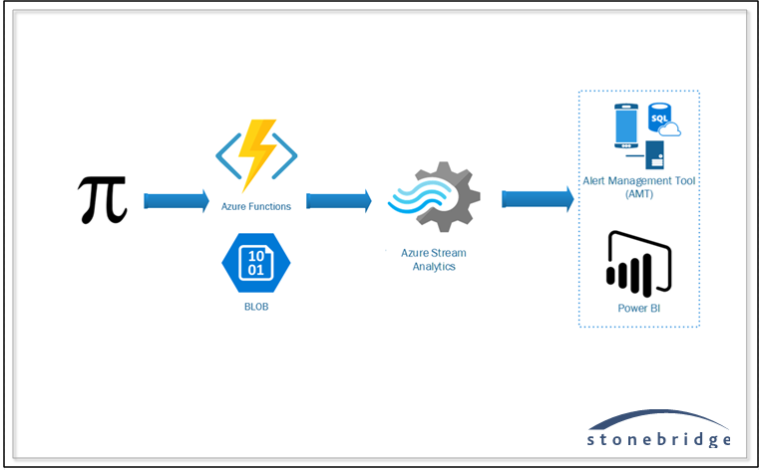

**Azure Components:** The diagram below shows the different components that were built on Azure to complement the architecture diagram.

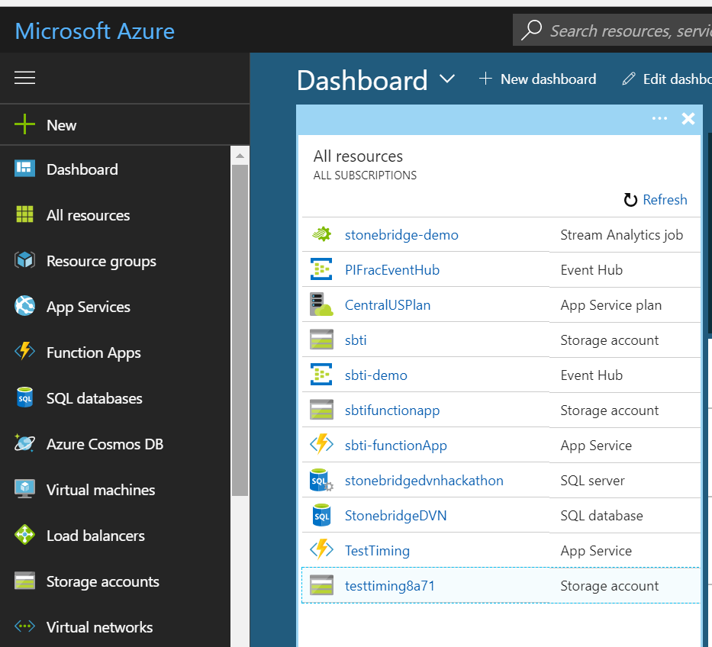

## Pi Data Collection

**Data Collected from PI Using Rest API:**

## 

## Stream Analytics

**Azure Stream Analytics:**

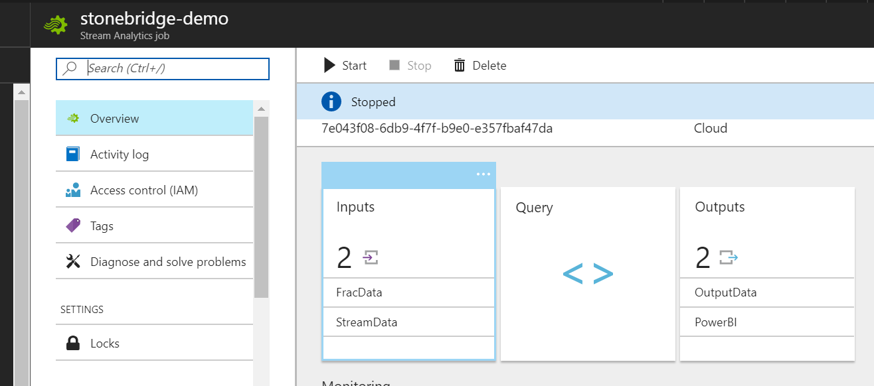

## Security

AMT will utilize the active directory system that is implemented. This will allow for ease and efficiency of manageing user accounts. There is a login screen for the mobile applications.

## Alert Management Tool (AMT)

The AMT interface is used to create and manage alerts utilizing the data stream coming from Pi. These data are collected during a hyrdaulic fracturing job.

**Categories of Alerts:**

* Alerts Templates– These are read only alerts setup by the completions engineer. They are viewable by the PIC, but are not editable.
* PIC Alerts – created and managed by the PIC. These alerts can be setup and managed by the individual PIC.

**Alert Management Interface:**

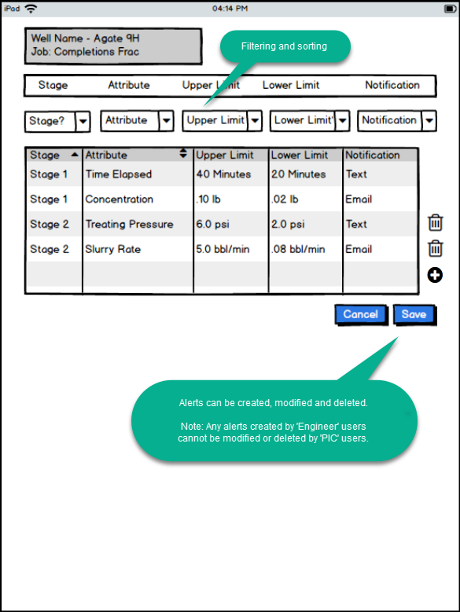

**Alert Notification Interface:**

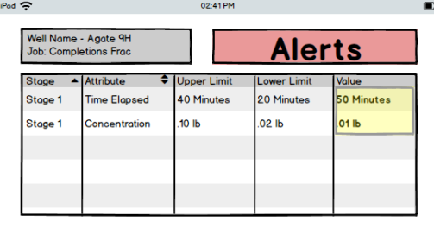

**Email Alert:**

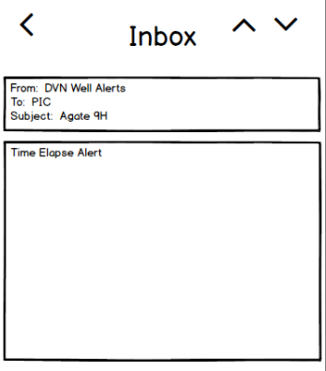

**Text Alert:**

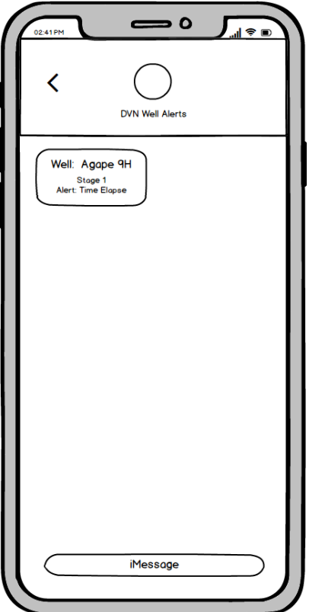

## Alert Analytics Data Structure

**Power BI Dashboard Using Alerting Metrics:**

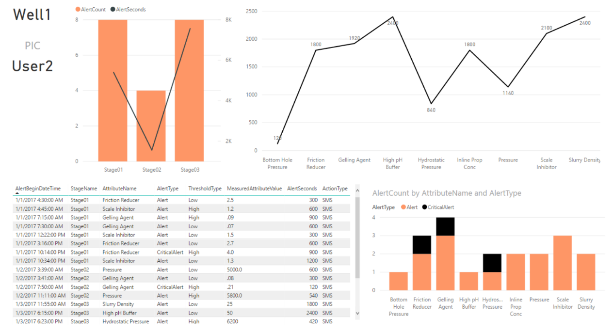

**Alerting Method:**

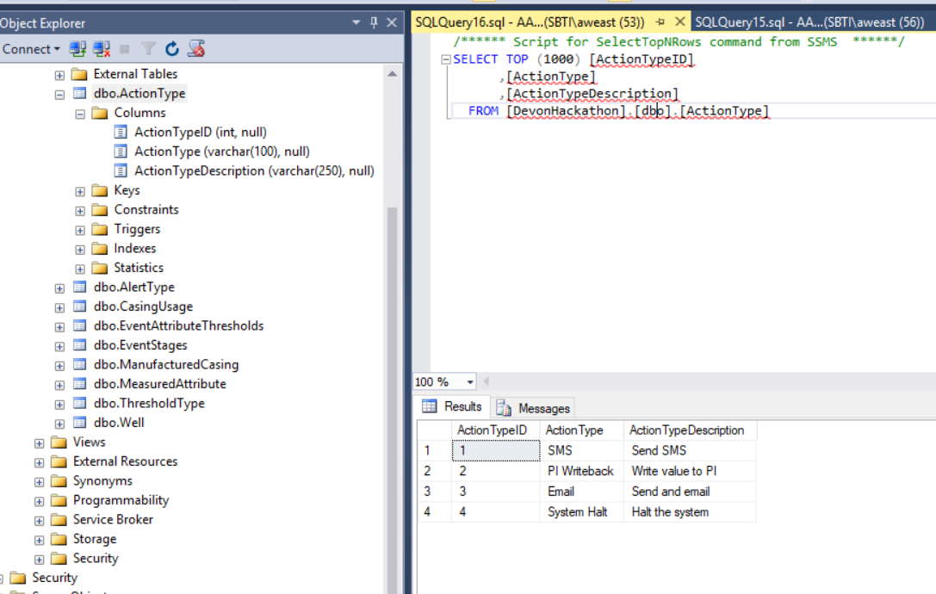

**Alert Type:**

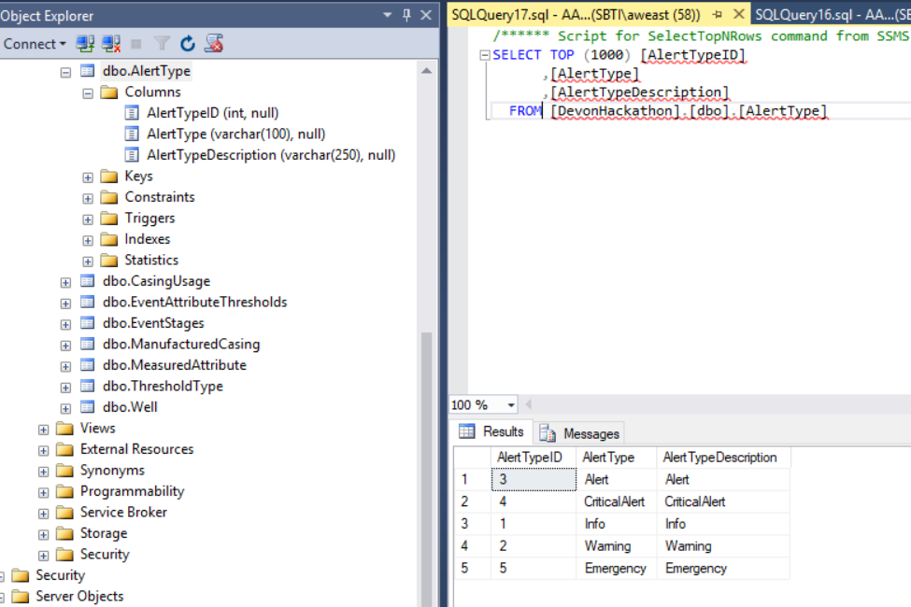

**Event Stage – event stages as defined in PI AF:**

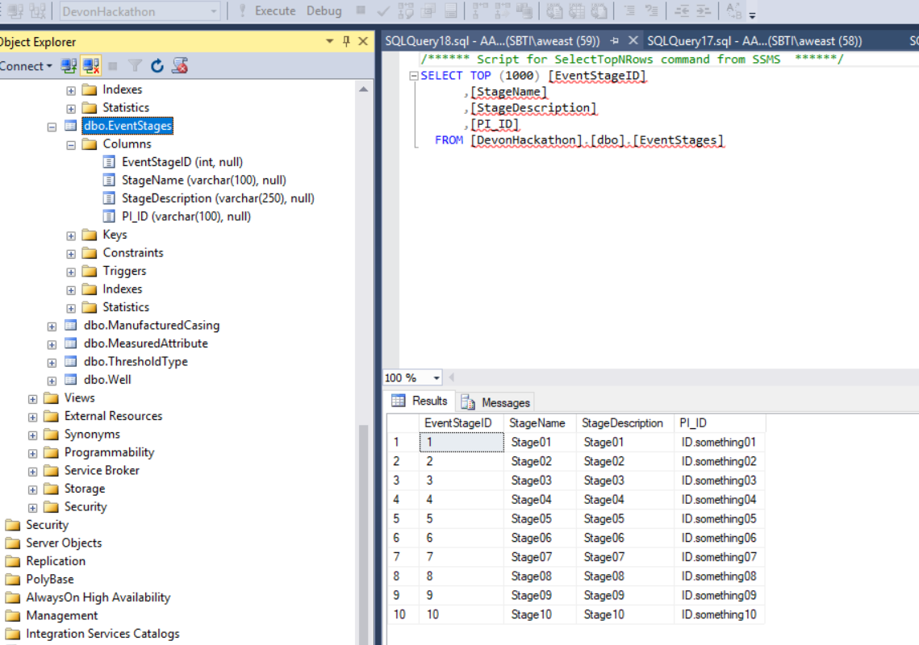

**Measurement Attribute – attributes being measured by PI to create events and alerts for:**

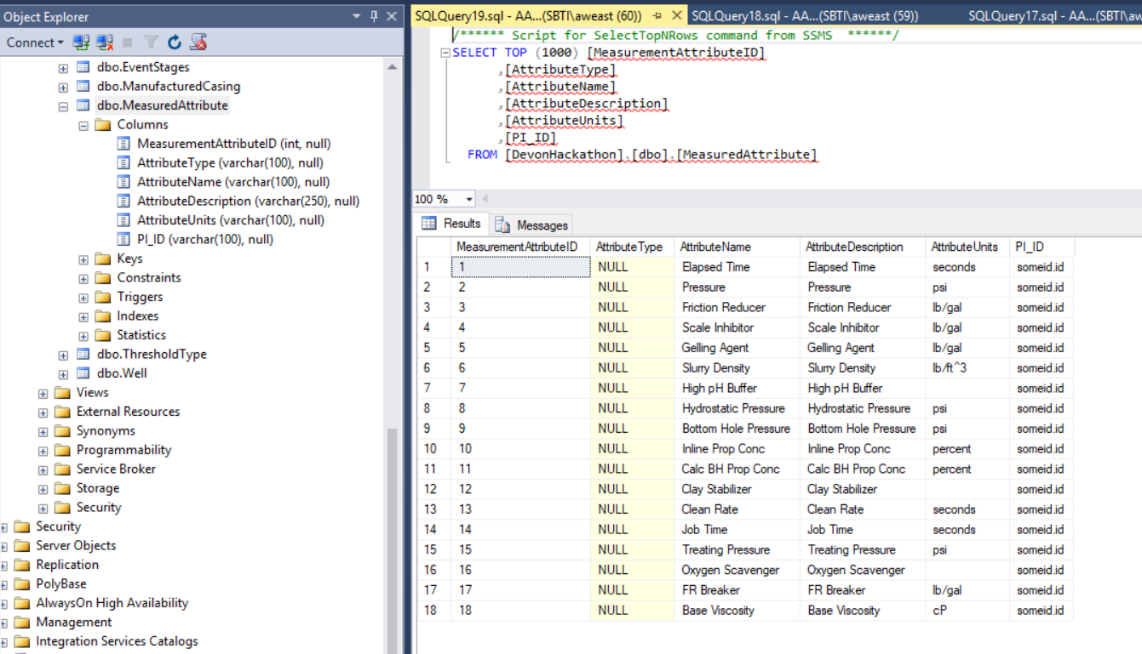

**Threshold Type – The types of thresholds that would be defined and monitored:**

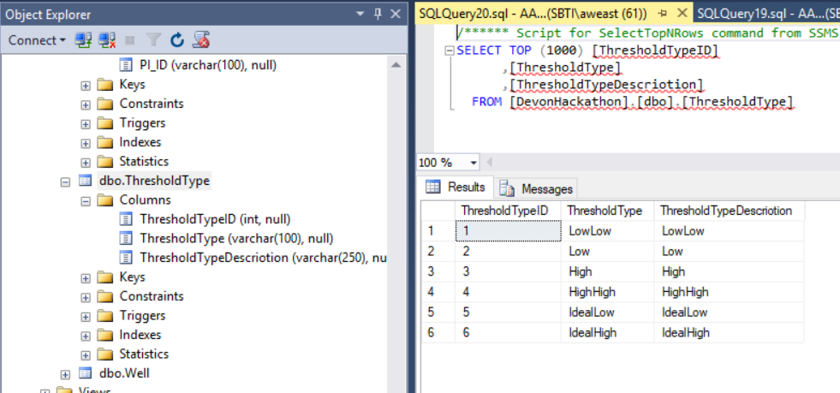

**Users – Utilize AD Security:**

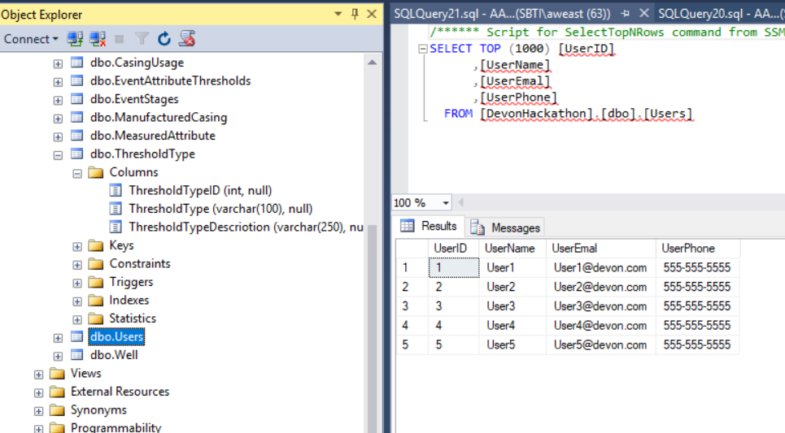

**Well – Populated from existing MDM solution:**

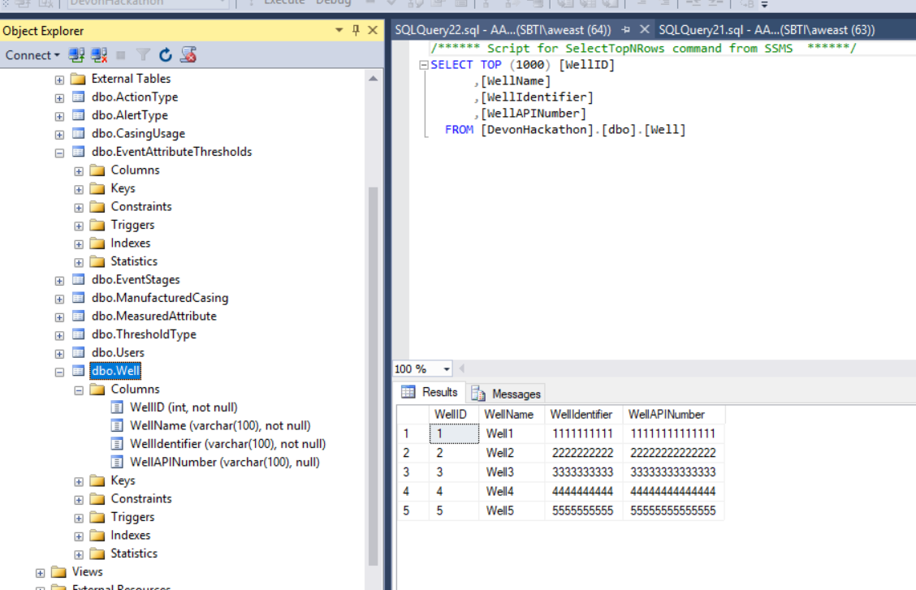

**Event Attribute Thresholds –** collecting events and thresholds to alert on by stage and well. Multiple alerts and thresholds per attribute and stage could be set. Engineers could have templates to “pre-set” most of this. The PIC could add extra alerts that they are concerned with.

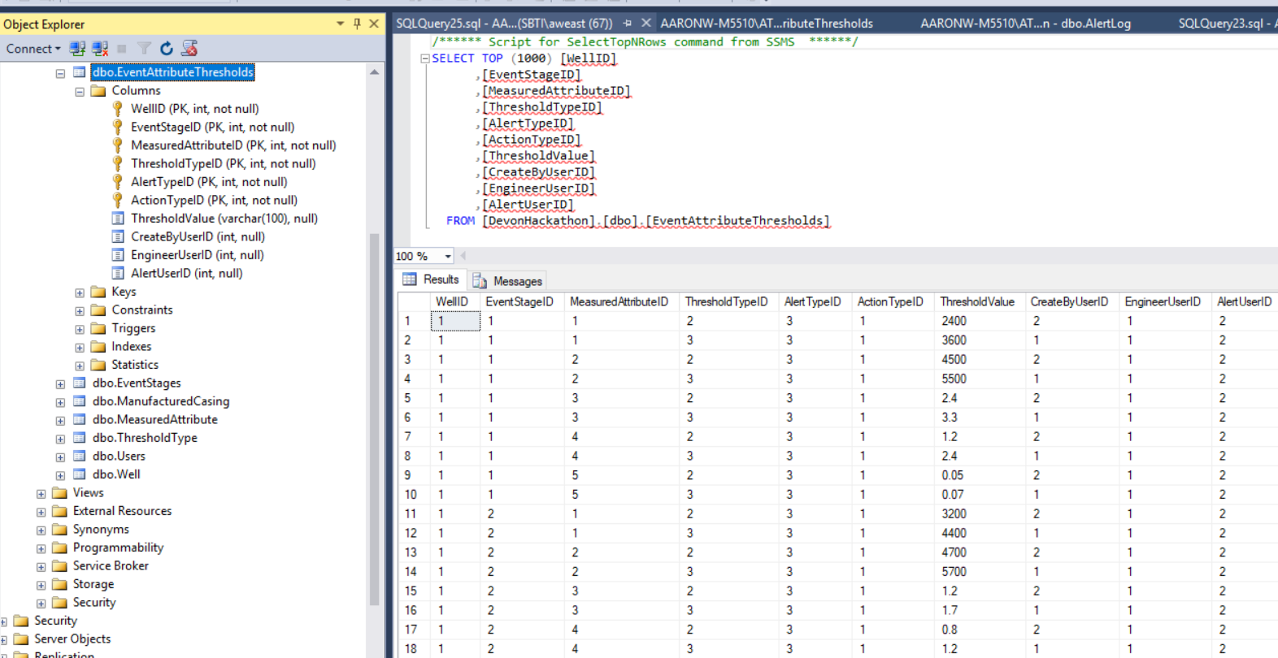

**Alert Log –** A log of the alerts sent

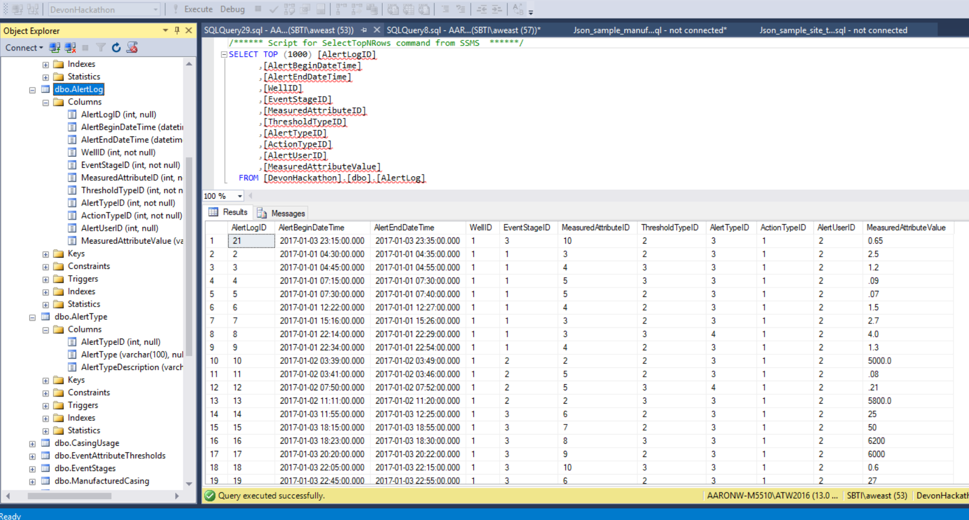

**Alert Details** – a view to pull the alert log and it’s dimensional descriptions together for analysis

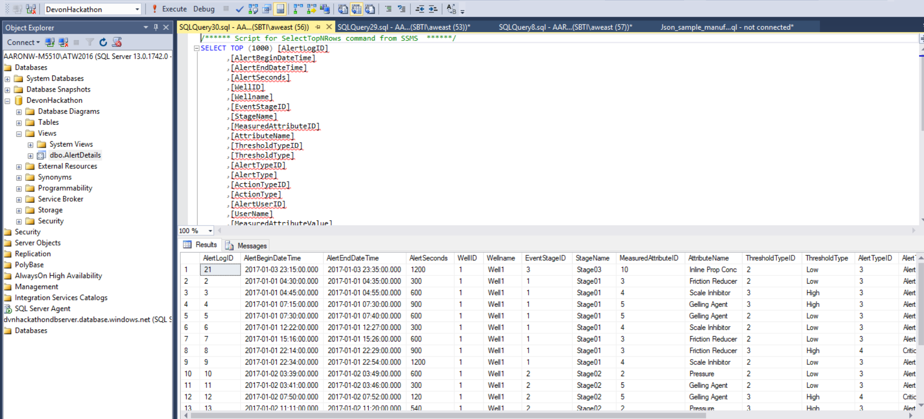

# Extended Solution

Utilizing the foundation implemented in the solution, there are many opportunities to extend the functionality of the AMT solution. Below is an architectural design for extending the capabilities of the existing solution.

